

May Newsletter

Dear Ruby,
As we move towards the summer months, May has been another busy and productive month both across the constituency and in Parliament.
Over recent weeks, I have continued meeting with residents, local businesses, schools, charities and community organisations to hear about the issues that matter most to local people. From supporting constituents through casework and advice surgeries to visiting community events and local employers, these conversations remain invaluable in helping me represent our area effectively.
This month’s newsletter includes updates on a number of visits across the constituency, including local schools, community groups, charities and businesses, as well as ongoing work to raise residents’ concerns on issues such as healthcare provision, local infrastructure and water supply resilience.
I have also been pleased to see the continued dedication of volunteers, community leaders and local organisations who work tirelessly to support others and strengthen our communities. It is always encouraging to see the positive impact their efforts have across our towns and villages.
Thank you to everyone who has contacted my office, attended a local event or shared their views with me over the past month. Your feedback and experiences help to inform the work I do both locally and in Parliament.

With best wishes,
Stuart
Rt Hon Stuart Andrew MP
Member of Parliament for the Daventry Constituency

Update on Palliative Care Provision at Danetre Hospital

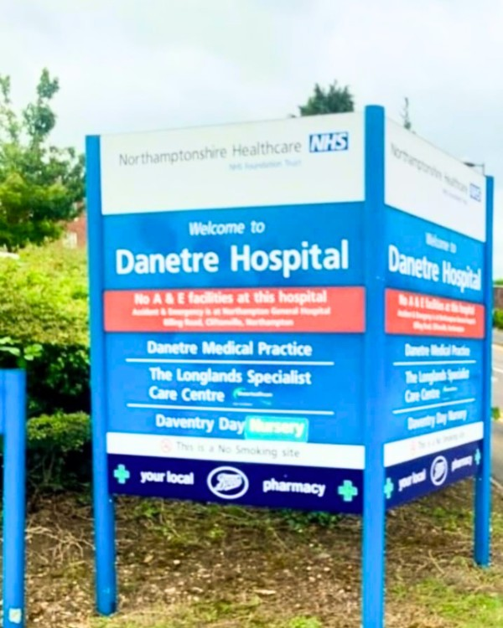

Following concerns raised by residents regarding palliative care provision at Danetre Hospital, Northamptonshire Healthcare NHS Foundation Trust (NHFT) has now provided an update on the current situation.
NHFT has confirmed that, due to a temporary shortfall in consultant cover, the palliative care beds are currently being used for rehabilitation care while recruitment takes place. They have also stated that the beds will return to palliative care provision once medical cover has been restored.
I understand that many residents will continue to have questions and concerns about the future of these important local services. In response, I am seeking a meeting with NHFT and the Integrated Care Board (ICB) to better understand their longer-term plans for Danetre Hospital.
Thank you to everyone who has taken the time to contact me regarding this issue. I will continue to keep residents updated as further information becomes available.

Raising Residents’ Concerns Over Water Supply Issues

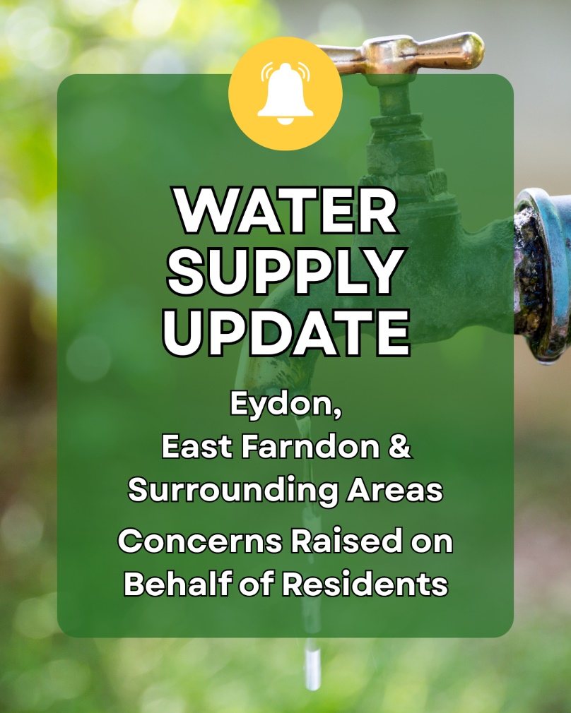

I know many residents in East Farndon, Clipston, Arthingworth, Great Oxendon and Eydon have been frustrated by the recent water supply issues affecting local communities, and I have received a significant number of communications from residents concerned about the disruption caused.
After raising residents’ concerns directly with Anglian Water, I am due to speak with the company’s Chief Executive, Mark Thurston, next week, to discuss the situation further.
Our discussions will focus on the recent pump failure, the support available to affected residents and the steps being taken to improve the long-term resilience of the local water supply network.
In the meantime, Anglian Water has asked customers to use water for essential purposes only while pressures on the network remain high.
Thank you to everyone who has contacted me regarding this issue. I will continue working with all parties involved and will keep residents updated as further information becomes available.

Daventry Motorfest Brings the Community Together

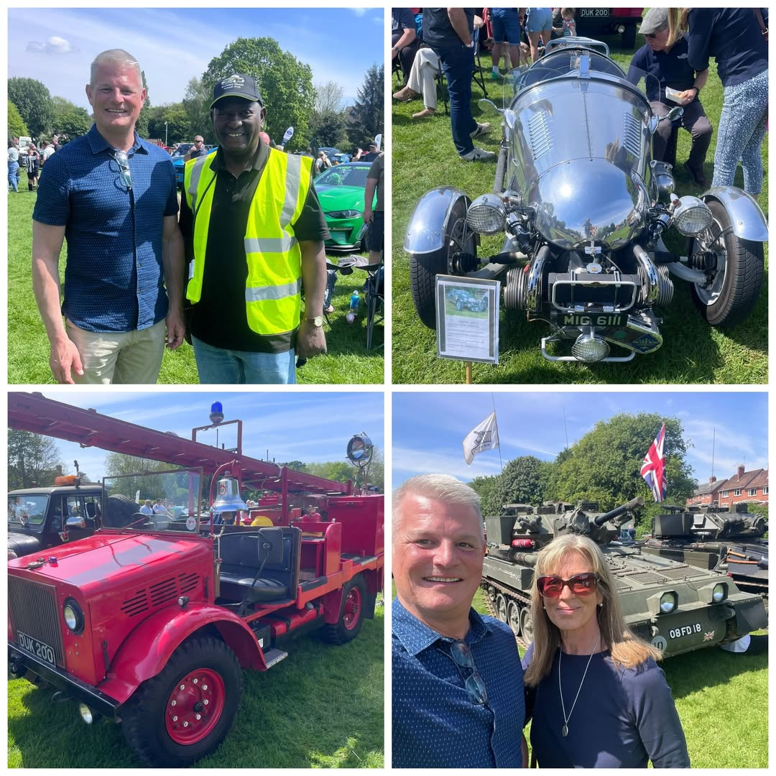

It was a pleasure to attend this year’s Daventry Motorfest at The Hollow and to see so many residents and visitors enjoying the event.
My thanks go to Cllr Phillip Silk-Neilsen for the invitation, as well as to the volunteers, organisers and everyone involved alongside Daventry Town Council in making the day such a success.
The event was a fantastic celebration of motoring heritage and a wonderful example of the strong community spirit here in Daventry. With excellent weather and a brilliant atmosphere throughout, it was clear how much hard work had gone into organising such an enjoyable occasion for all ages.

Supporting Mental Health and Wellbeing

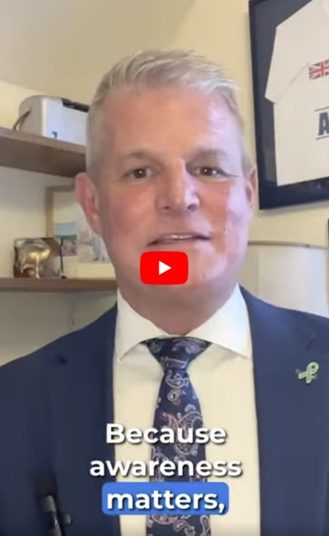

Mental health and wellbeing affect us all, and throughout Mental Health Awareness Week there has been an important focus on encouraging people to take action and support one another.
Alongside my colleagues Dr Luke Evans MP and Dr Caroline Johnson MP, I was pleased to support this important campaign and help raise awareness of the importance of mental wellbeing.
Sometimes taking action can be as simple as checking in on a friend, making time to talk, or reminding someone that they do not have to face challenges alone. Being kinder to ourselves and to each other can make a real difference.
Small actions matter, and by supporting one another we can help build stronger, healthier communities for everyone.

Meeting Residents Across the Constituency

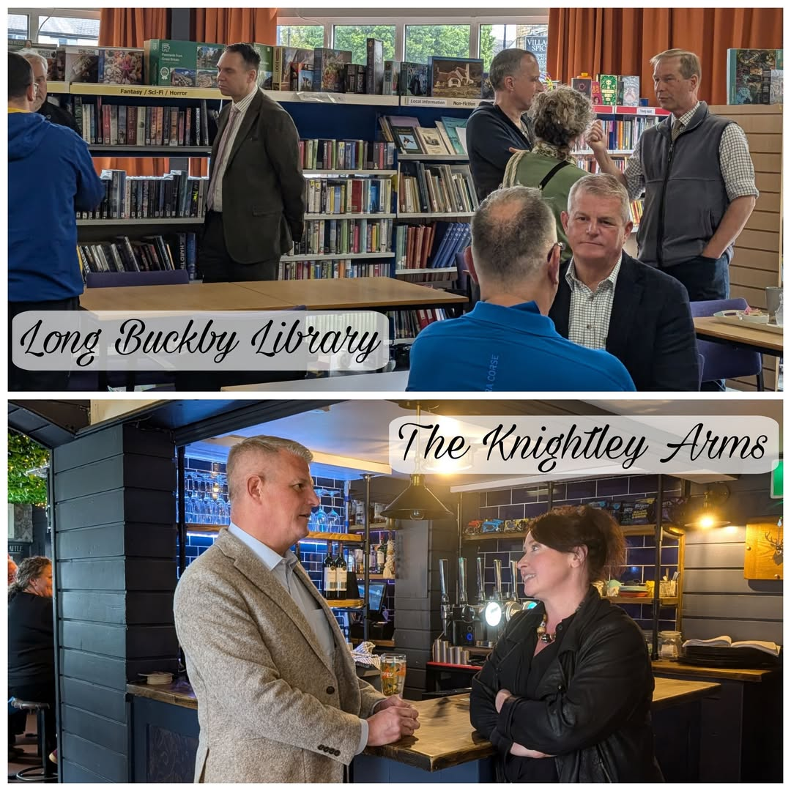

Over recent weeks, I have enjoyed meeting residents at a number of community events and advice sessions across the constituency.

It was a pleasure to welcome both new and familiar faces at the recent Meet Your MP event at the Knightley Arms in Yelvertoft, and my thanks go to Jackie for kindly hosting the evening.

I also joined West Northamptonshire councillors Daniel Lister and Charles Morton, alongside local parish councillors, for a coffee morning at Long Buckby Library. The event provided an excellent opportunity to discuss local issues, hear residents’ views and talk about the matters that are most important to the community.

This was followed by a fully booked advice surgery, where I was able to support constituents with a wide range of individual concerns and casework matters.

Thank you to Long Buckby Library for hosting these events, and to everyone who took the time to come along and share their views. If I can be of assistance, or if you would like to arrange an appointment at a future advice surgery, please do get in touch with my office.

Advice Surgeries - Dates & Locations

Visiting a Local Dairy Farm in Welton

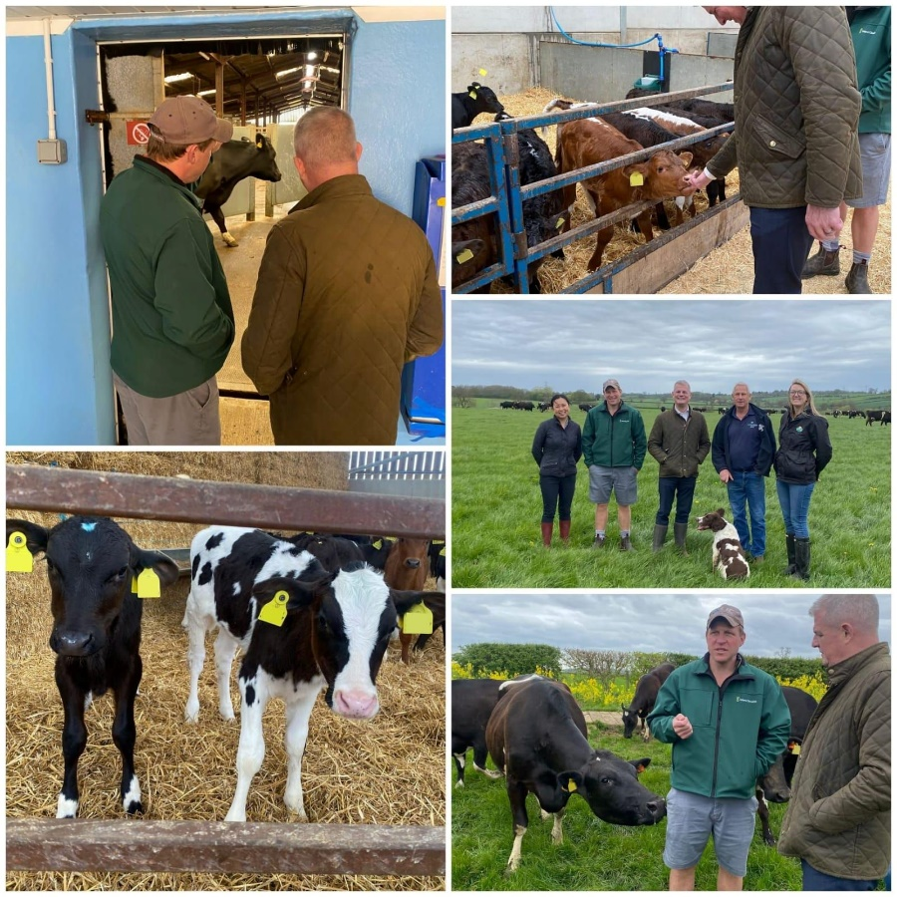

I recently visited Matt’s farm in Welton alongside representatives from Tesco and Arla to learn more about the important work taking place within our local farming community.
The farm runs an impressive operation of around 600 grazing cows across more than 400 hectares, supplying milk through Arla to Tesco. It was fascinating to see the level of innovation and technology now being used in modern farming, including health-monitoring systems designed to support animal welfare and improve herd management.
During the visit, we also discussed key issues facing the agricultural sector, including food security, the future of farming and the importance of encouraging more young people to consider careers in agriculture.
It was a valuable and insightful visit, and a strong reminder of the vital role local farmers play in supporting both our economy and the nation’s food supply.

Visiting Glenvale CofE Primary School

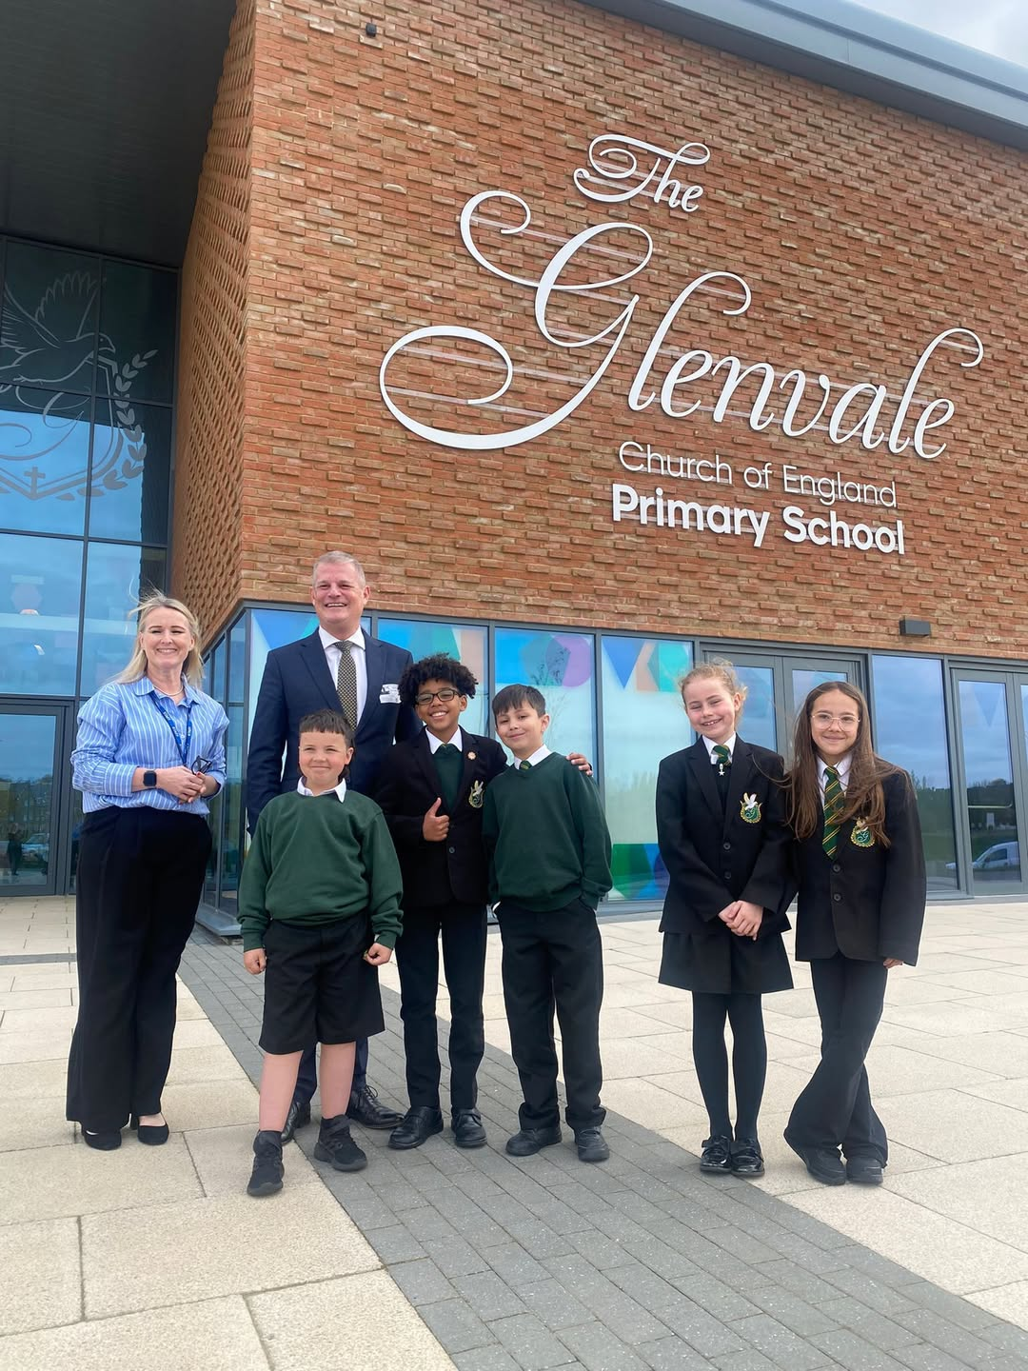

I recently had the pleasure of visiting Glenvale CofE Primary School to meet pupils and staff and learn more about the excellent work taking place across the school community.
It was particularly encouraging to meet the school’s Eco Team and hear about the initiatives they are leading to promote energy and water conservation, as well as their plans for litter picks and fundraising for new equipment.
During the visit, I also joined a school assembly for a question-and-answer session with pupils, who asked a number of thoughtful and engaging questions about life as a Member of Parliament.
Thank you to everyone at Glenvale CofE Primary School for the warm welcome, the tour of the school and for sharing plans to further develop the outdoor areas. It was a real pleasure to visit such a welcoming and forward-thinking school community.

Joining Welford, Sibbertoft and Sulby School’s First Walking Bus

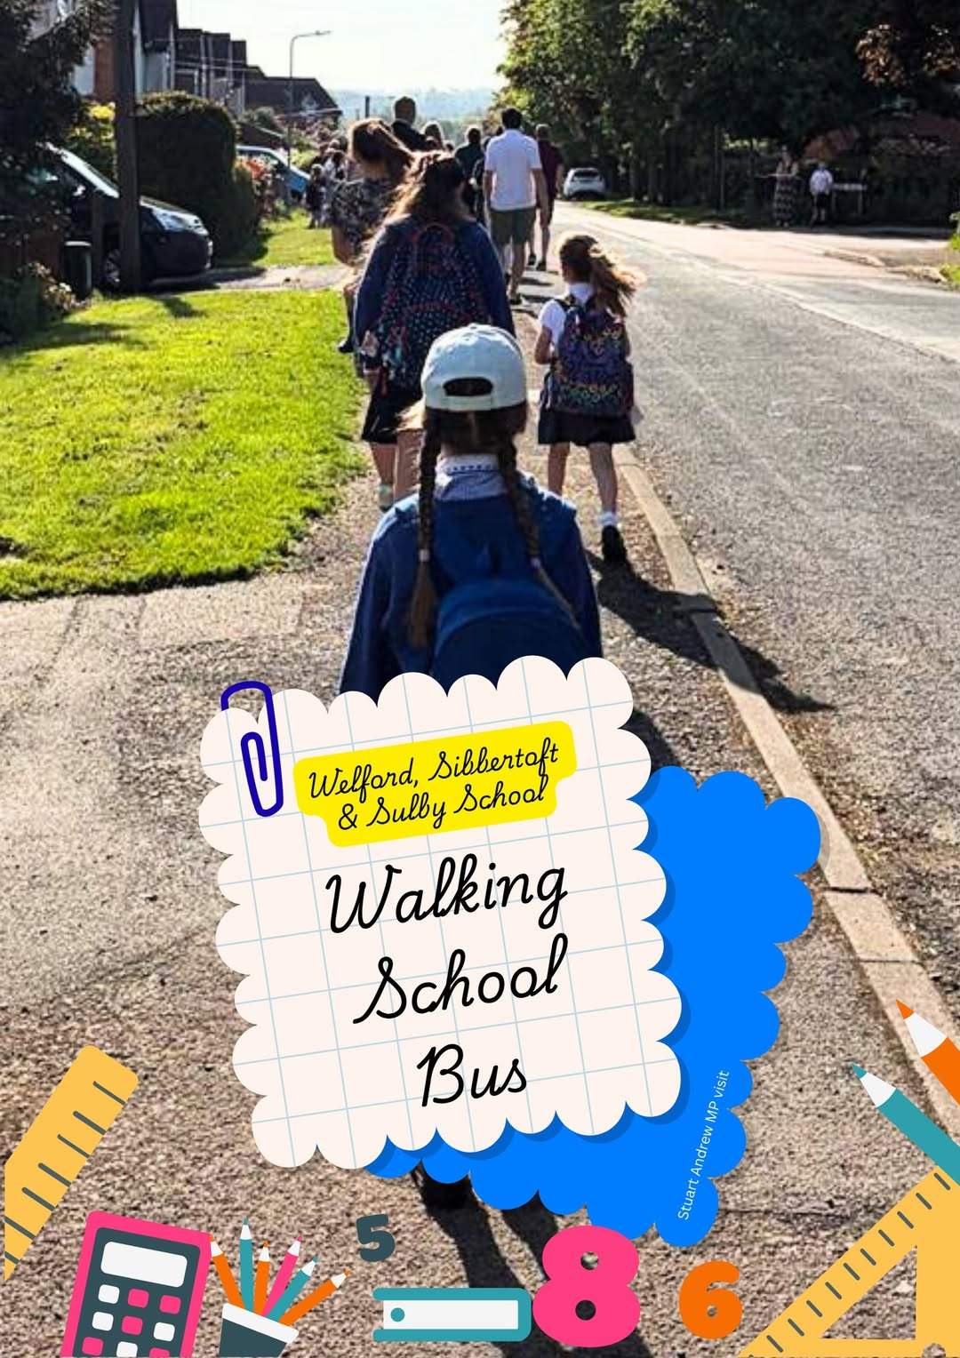

I recently had the pleasure of visiting Welford, Sibbertoft and Sulby School and joining pupils, families and staff for the school’s very first Walking Bus initiative.
It was wonderful to see so many families taking part and waiting along the route to walk to school together. The event created a fantastic atmosphere and highlighted the value of encouraging healthy, active travel while bringing the wider school community together.
During the visit, I also enjoyed meeting members of the school’s Eco Squad and hearing more about the various environmental projects they have been leading throughout the year. It was encouraging to see such enthusiasm and commitment from pupils towards sustainability and caring for their local environment.
Thank you to everyone at Welford, Sibbertoft and Sulby School for the warm welcome and for inviting me to be part of such a positive community event.

Visiting Maggie’s Northampton

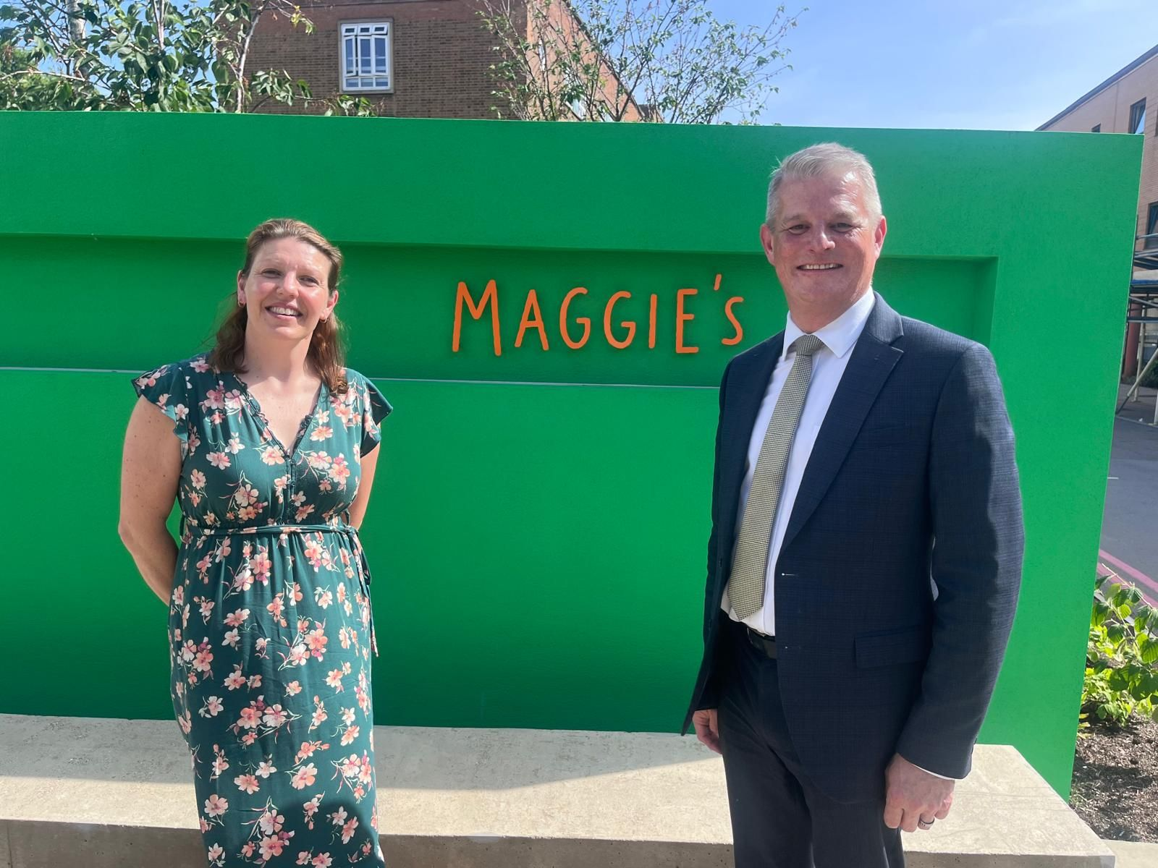

It was a pleasure to visit Maggie’s Northampton recently to learn more about the incredible support they provide to cancer patients and their families.
Maggie’s offers vital practical and emotional support for people affected by cancer, creating a welcoming space for both patients and carers during what can often be a very difficult time.
During the visit, we discussed ways to help raise awareness of the centre and explored ideas for future fundraising to support their important work.
Thank you to everyone at Maggie’s Northampton for taking the time to show me around and for the compassionate care and support you provide to so many people across Northamptonshire.

Visiting Mercedes-AMG High Performance Powertrains in Brixworth

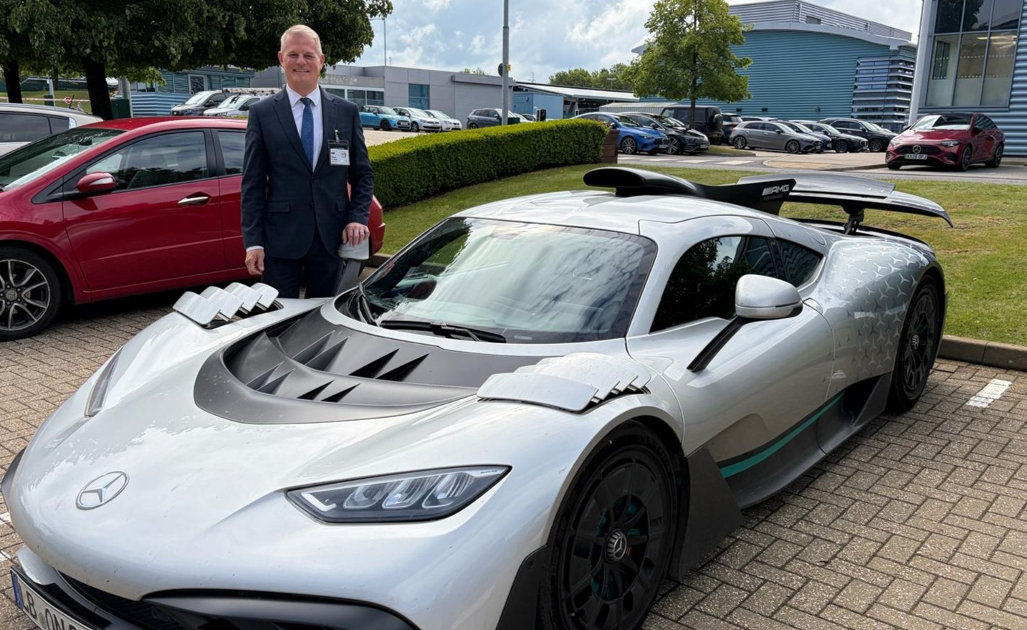

I recently visited Mercedes-AMG High Performance Powertrains in Brixworth to learn more about the company’s world-leading engineering work and discuss the challenges surrounding future energy supply to the site.
Mercedes-AMG HPP is a major local employer, supporting around 1,000 jobs and producing Formula 1 power units and advanced automotive technologies used across the world. During my visit, I met with members of the leadership team and toured the facility to hear more about their work and future plans.
A key part of our discussions focused on the need for a reliable and sustainable energy supply to support continued investment, innovation and local employment. The company has raised concerns regarding delays to the infrastructure improvements needed to meet its future energy needs.
It was also valuable to hear more about the business’s sustainability ambitions and its ongoing contribution to the local economy.
Thank you to everyone at Mercedes-AMG HPP for the warm welcome and informative discussions.

Visiting Art Expressions UK CIC

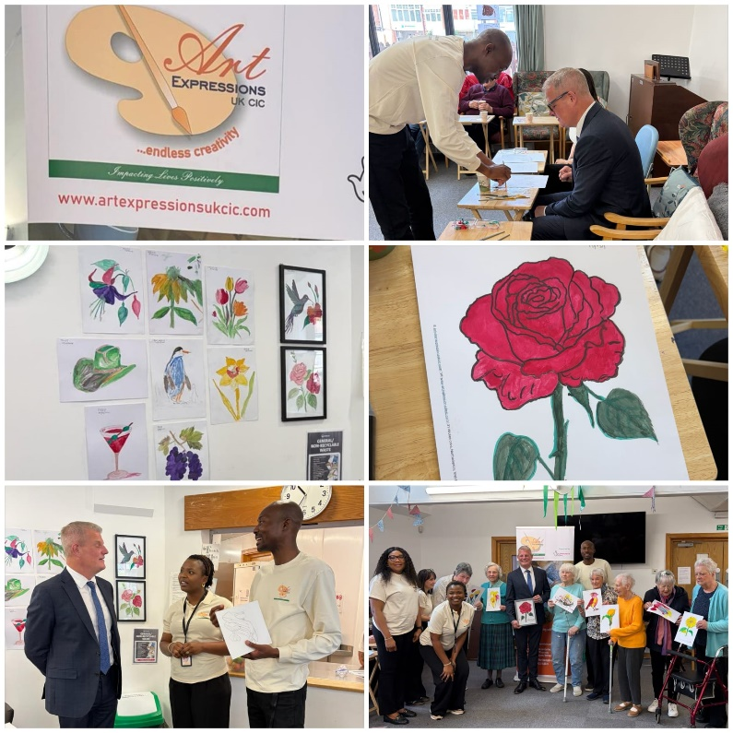

I recently visited Art Expressions UK CIC at the Venton Centre to learn more about the organisation’s work using art to support wellbeing, confidence and self-expression within the local community.
During the visit, I met participants taking part in a session delivered in partnership with Age UK Northampton, viewed some of the fantastic artwork on display and heard more about the positive impact these workshops are having on wellbeing and social connection.
It was also encouraging to learn about the organisation’s recent National Lottery Community Fund grant, which will help support and expand this valuable work across Northamptonshire.
Thank you to everyone at Art Expressions UK CIC for the warm welcome and for the important contribution you are making to the lives of so many people through creativity, inclusion and community engagement.

Supporting Constituents Across the Daventry Constituency

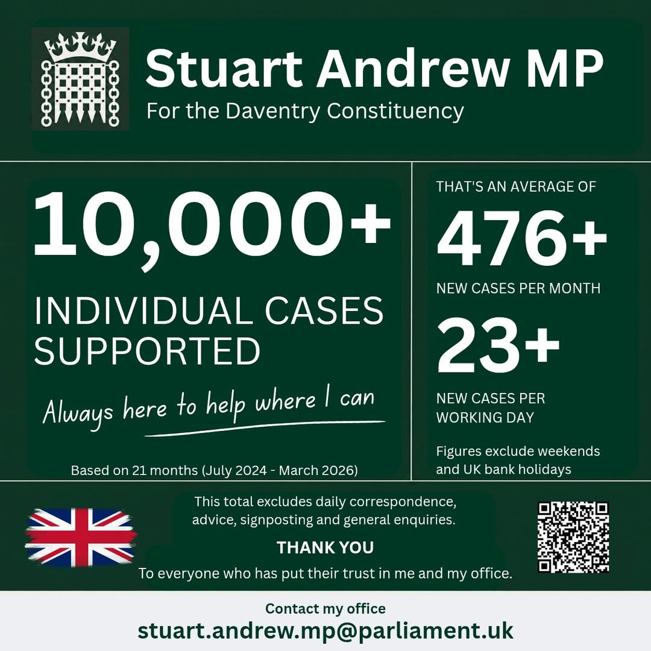

Since July 2024, my office has supported constituents through more than 10,000 individual cases across the Daventry constituency.
These cases have covered a wide range of issues, including housing, healthcare, immigration, benefits, local services and many other matters raised by residents seeking assistance.
Helping constituents and supporting those facing difficulties remains one of the most important parts of my role as a Member of Parliament, and I am grateful to everyone who has contacted my office and placed their trust in us to help resolve their concerns.
If you require assistance with a local or national issue, please do not hesitate to get in touch at stuart.andrew.mp@parliament.uk.

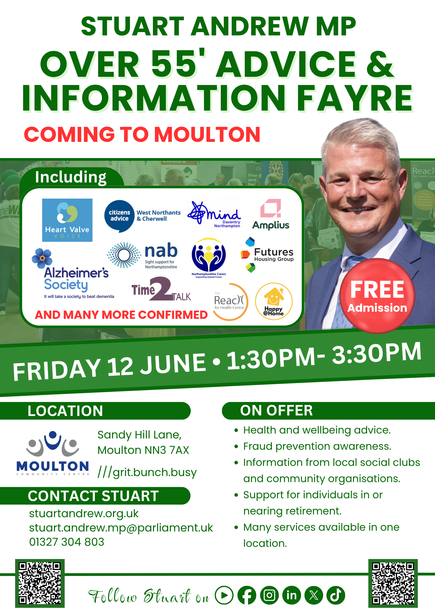

Westminster Roundup

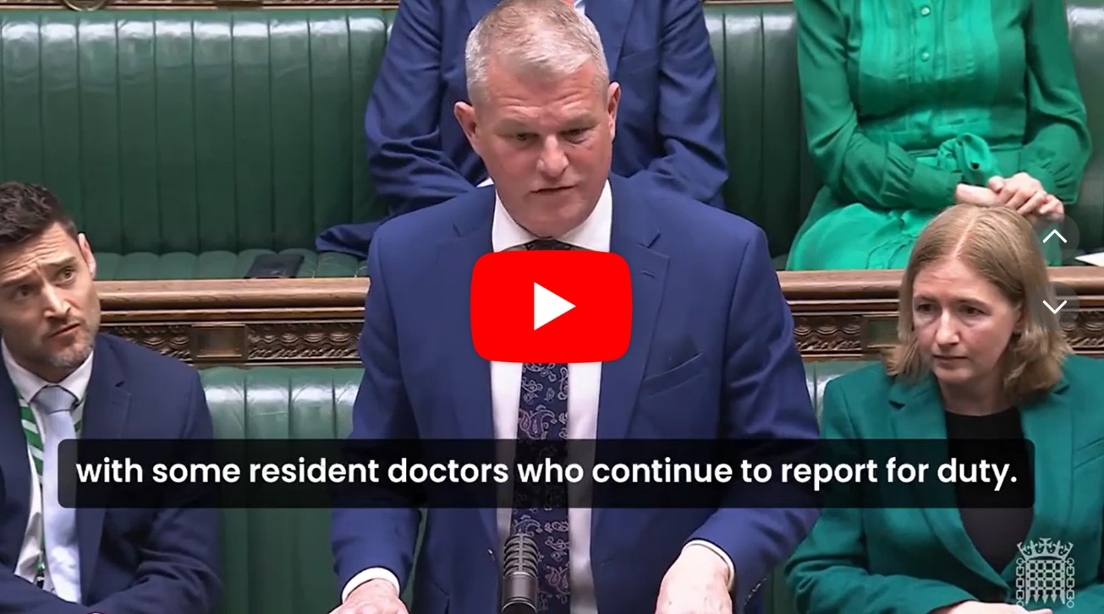

Parliament returned for the opening of the new Session, with the first two sitting weeks dominated by the State Opening and debate on the King’s Speech.
- The State Opening of Parliament took place, with MPs summoned to the Lords to hear the King’s Speech from the Throne, setting out the Government’s legislative agenda for the new Session.
- In the Commons, the debate began on the King’s Speech, with themed debates covering the Government’s priorities for economic growth, energy security, and defence readiness.
- Routine Commons business resumed alongside the King’s Speech debates, including Business Questions to the Leader of the House and departmental questions to Justice, Science, Innovation and Technology, and Business and Trade Ministers.
- Early procedural business for the new Session included nominations and, if necessary, the election of the Chair of the Backbench Business Committee, as well as the Private Members’ Bill ballot.
- Other Commons and Westminster Hall business covered issues including the Steel Industry (Nationalisation) Bill, unadopted roads and public amenities on new developments, the impact of a third runway at Heathrow Airport, censorship of women’s health content online, and domestic abuse and safeguarding.
The Commons rose at the end of the second sitting week for the Whitsun Recess.

Contact Me
The best way to reach me is by email or post.
Please include your full address, including postcode, in all communications.
Rt. Hon. Stuart Andrew MP
Icon Innovation Centre,
Daventry,
Northamptonshire
NN11 0QB
Email: stuart.andrew.mp@parliament.uk
PS. Reminder that this is only a selective snapshot of the work I do and won't cover every single issue/topic/community.

